**ĐẠI HỌC QUỐC GIA THÀNH PHỐ HỒ CHÍ MINH**

**TRƯỜNG ĐẠI HỌC CÔNG NGHỆ THÔNG TIN**

**--------------------oOo--------------------**

**KHAI THÁC DỮ LIỆU**

**(Data Mining)**

**LAB 4**

Giảng viên hướng dẫn:

**ThS. Lê Hà Hoài Trung**

Sinh viên thực hiện:

**Hoàng Lê Nam – MSSV: 18521120**

🙡🙢 Tp. Hồ Chí Minh, 3/2021 🙠🙣

Mục lục

**I.** **Hướng dẫn chung** 2

**II.** **Thực hành** 7

**Bài 1** 7

**Bài 2** 17

**Bài 4** 28

**Bài 5** 37

**Bài 6** 45

**Bài 7** 53

1. **Hướng dẫn chung**

1. **Thực hành**

**Bài 1**

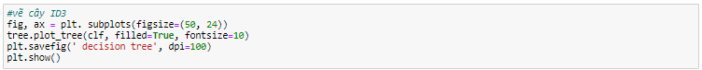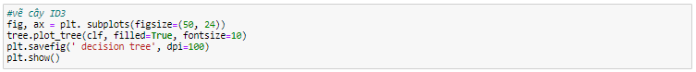

**Bài 2**

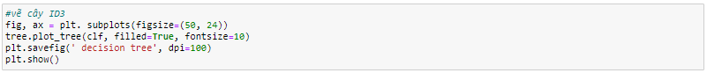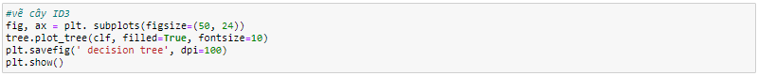

**Bài 3**

Phần yêu cầu lập trình phía trên

**Bài 4**

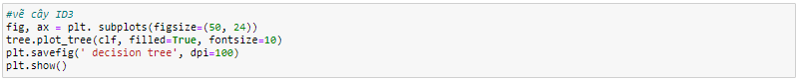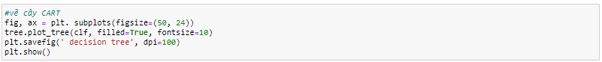

**Bài 5**

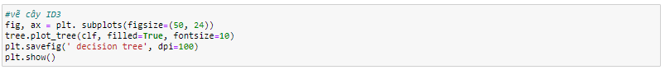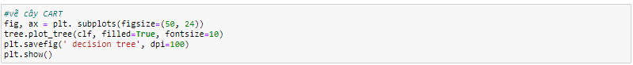

**Bài 6**

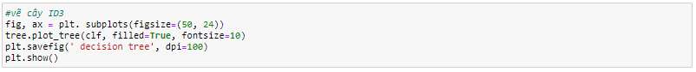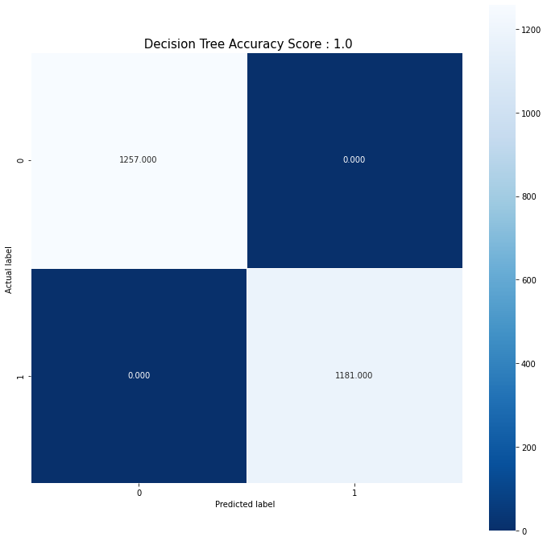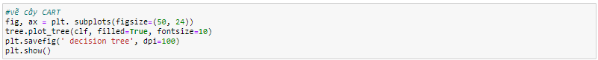

**Bài 7**

